Objective
In this exercise you will learn how to create a simple map in ArcGIS, by adding, displaying and symbolizing data, and then creating a map layout.

Data
counties.shp, elevation LIDAR dataset

The GIS Project

1. Open ArcMap. Choose to create a new map from scratch.
2. Add data with the button.

3. Browse to the map 4 folder, and choose to add the counties.shp layer. This is a shapefile containing the county boundaries for North Carolina.

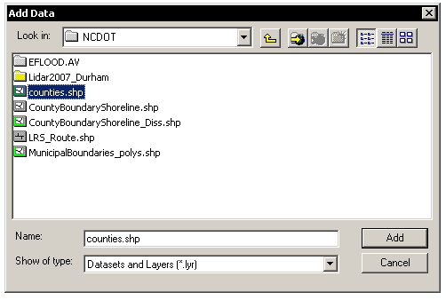

4. Use the select tool to select Durham County. It should be outlined in blue (or another color, if you changed your selection color).
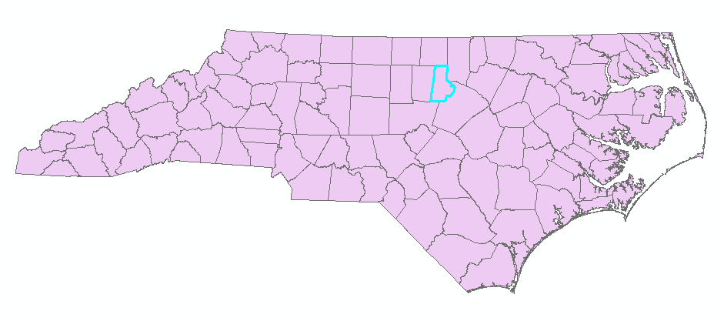

5. Right click on the word counties in the layers menu. Choose Selection and then Create Layer From Selected Features.

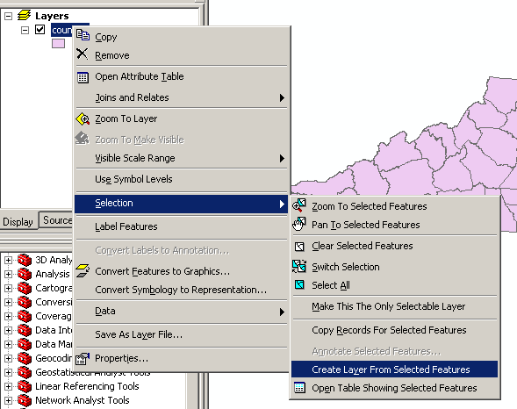
6. You should now have two layers, counties and counties selection. Right click on the counties layer, and remove it. You should now only have a Durham county layer visible. Right click on it and choose Zoom to Layer to zoom in.

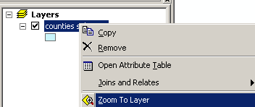

7. Click on the add data button again and double click on the Lidar2007_Durham folder, then the Elevation_Grid folder, and add the elevation raster. Raster datasets are different than the vector datasets we have been working with. They are based on a system of grid cells and are often used for elevation, aerial photos, or other continuous surfaces.

8. Change the symbology on the elevation grid by right clicking it and choosing Properties. Click on the Symbology tab. Choose a color ramp that best represents elevation, and click Ok.

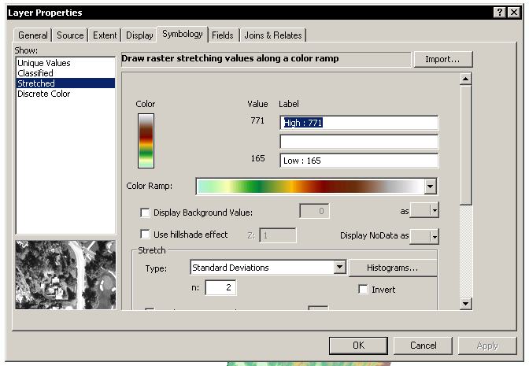

9. Right click on the counties_selection layer and go to Properties. Click on the Display tab. Set the transparency to 50%. When you click, you should be able to see the elevation grid through the county outline.

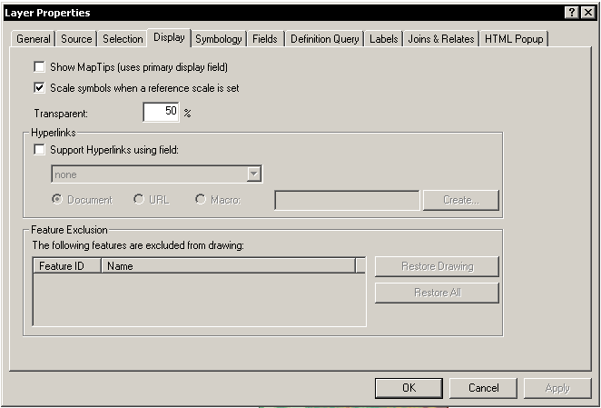

10. Click on the View menu and switch to layout view. Right click on your map of Durham and choose Distribute > Fit to Margins to fit your map to the page.

11. Use the Insert menu to insert a Title, Legend, Scale Bar and North Arrow into your map.

12. Also use the Insert menu to add a new Data Frame. In this new Data Frame, use the Add Data button () to add the counties.shp layer again.

13. Go to the Data Frame properties by rick clicking on the words New Data Frame, and choosing Properties. Click on the Extent Rectangles tab. On the list of Other data frames, choose the Layers data frame, and click the arrow button to move it over to the Show extent rectangle for these data frames list. Click Ok.
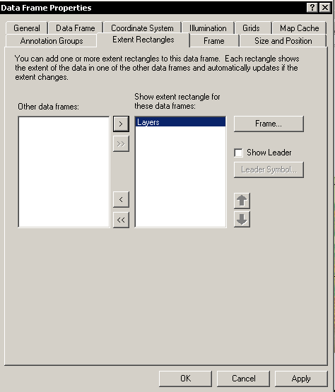

14. Move your various map elements around to create a layout to your liking. 