Objective
The objective for this exercise is to create a basic road network map for a county. We will discuss how to symbolize and label multiple classes of features. We will focus on line features, but these principles can be applied to both point and polygon features as well.
Skills
This exercise will introduce symbolizing multiple categories along with complex labeling and label positioning.
Data
You will need two shapefiles to complete this exercise: NCCounties.shp and NCRoads.shp
1. Open ArcMap. Click the launch ArcMap icon. The ArcMap program should begin to startup.

2. When the program loads, a starting window in ArcMap will appear. Select Start using ArcMap with A new empty map.
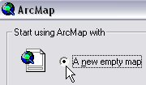

3. Add data to the project. Click the Add Data icon. In the Add Data window, navigate to the files that will be used for this project. Add NCCounties.shp and NCRoads.shp (they can be added at the same time by clicking and dragging the mouse over both files). Click Add. The files should now be viewable in the map display window.

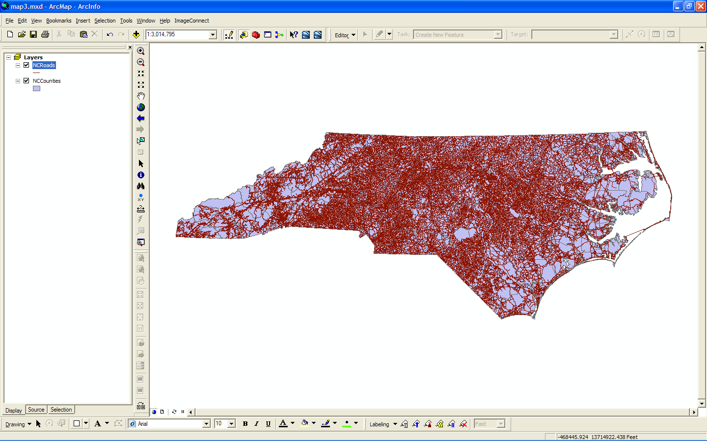

4. View Attribute Table. For the NCRoads file, right-click the file name and select Open Attribute Table. The attribute table displays information about the file. See illustration below.

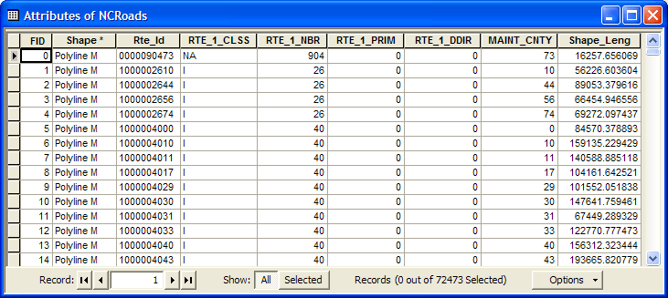

Notice the column ‘RTE_1_Class’. This is column we will use to symbolize the different categories of roads.

5. Change the symbology for NCCounties. Single-click the color box under the file name NCCounties. The Symbol Selector window should open. Change the Fill Color to Gray 10% and change the ‘Outline Width’ to 2.00 and the ‘Outline Color’ to ‘Arctic White’. Once you have the counties symbolized zoom in to your own county.

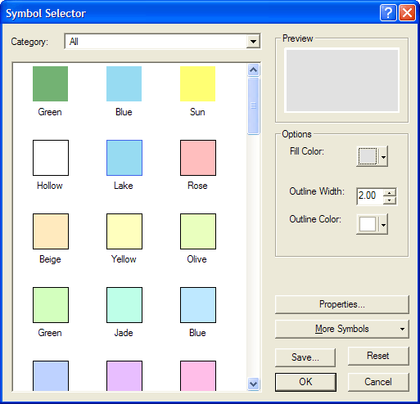

6. Change the symbology for NCRoads. Right-click the file name and select Properties. The Layer Properties window should open. In the Layer Properties window, click the Symbology tab. On the left-side menu, click Cataegories > Unique values. New options should be available to choose from. In the Value field section, change the Value field by clicking the drop-down menu. Choose RTE_1_Class. Finally, choose ‘Add All Values’, which will add all the unique values of the RTE_1_Class column. Now you should see something similar to this:
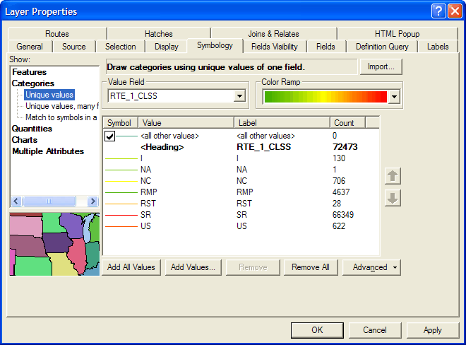

7. Remove any classes that we do not want to symbolize. Select NA, RMP, and RST by clicking each value and holding the control button.
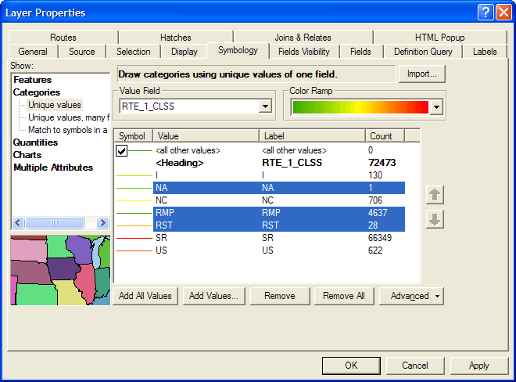

Then click ‘Remove’. You will be left with the I, NC, SR, and US categories.

8. Symbolize the individual categories by right-clicking on the value and selecting ‘Properties for Selected Symbol(s)’.

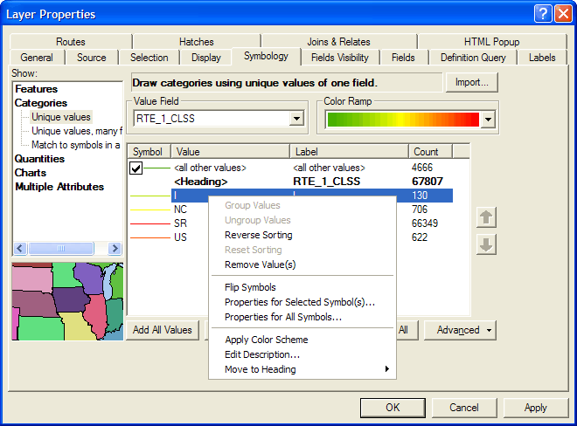

This will open the ‘Symbol Selector’ box that will allow you to change the symbology of the category. Here choose ‘Expressway’ and change the color to ‘Ultra Blue’. Now you will need to change the symbology for each of the other categories. For ‘US’ choose ‘Major Road’. For ‘NC’ choose ‘Arterial Street’ and change the color to Gray 70%. For ‘SR’ choose ‘Residential Street’ and change the color to Gray 30%. Uncheck the box next to the ‘<all other values>’ symbol.

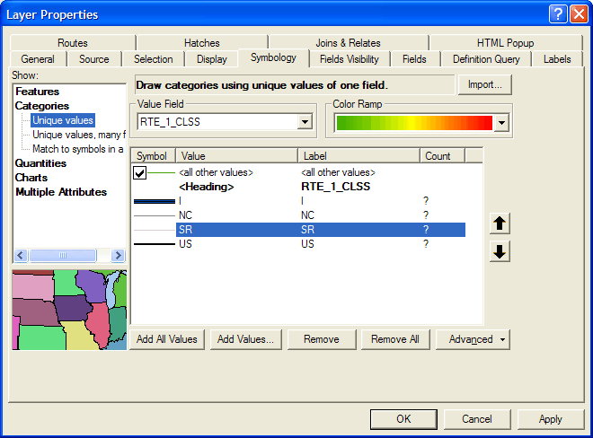

9. Now we have to order the individual classes so they draw appropriately. Click ‘Advanced’ and select ‘Symbol Levels’.

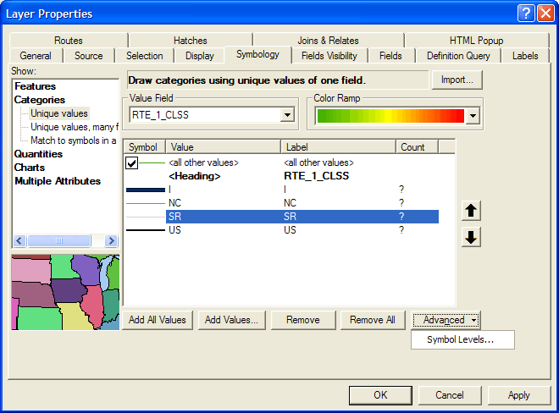

The ‘Symbol Levels’ box will allow you to control the drawing order of individual the individual categories you have symbolized.
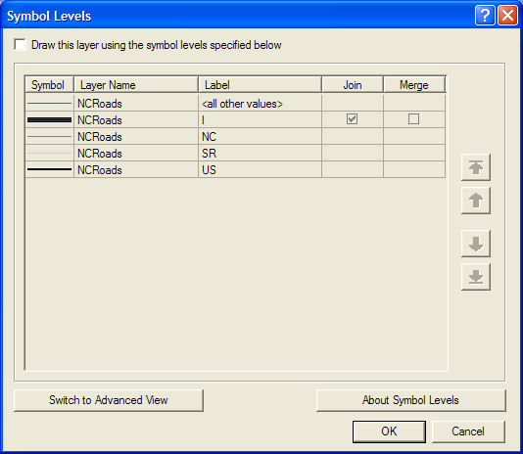

Check the ‘Draw this layer using the symbol levels specified below’ box. Select the ‘US’ label and using the arrows on the right side move it just below the label ‘I’.

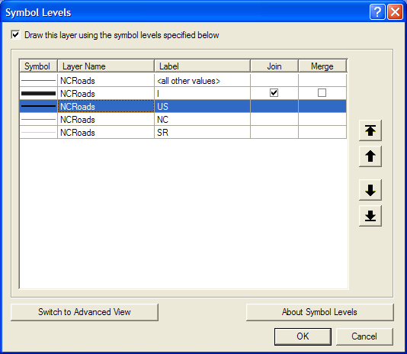

Now your individual road categories will draw Interstates, then US routes, then NC routes, and finally State Roads. Click ‘Ok’ then ‘Ok’ again. Now your map should look something like this:

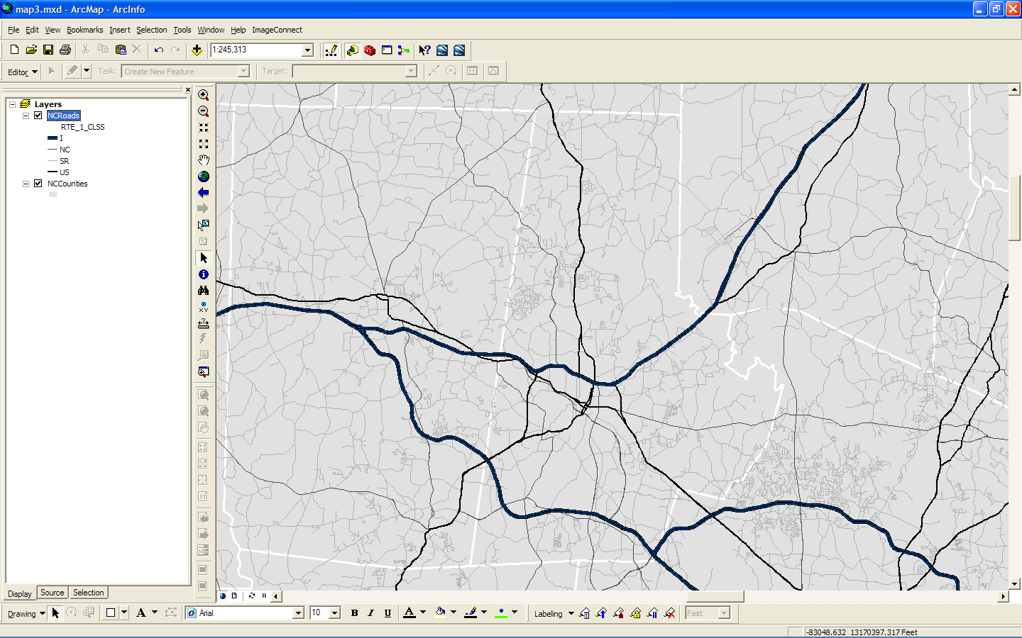

10. Now that the individual classes are symbolized you can create distinct labels for each. Right-click the NCRoads layer and open the properties. Select the ‘Labels’ tab.
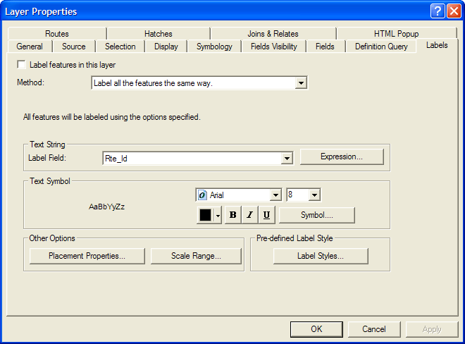

From the ‘Method’ dropdown box select ‘Define classes of features and label each class differently.’ Next click the ‘Get Symbol Classes’ button. Now under the ‘Class’ dropdown list you should see your 5 different road classes.
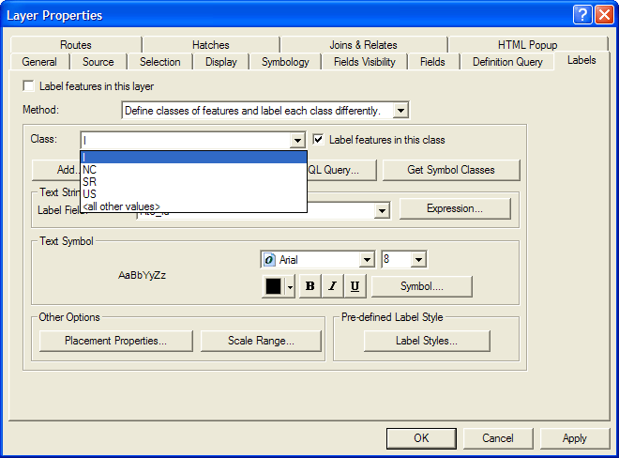
1
2
3

Now for each symbol class you can define a different label. This is especially helpful for labeling road classes with different types of highway markers and text labels.

For the ‘I’ symbol class select ‘RTE_1_NBR’ from the ‘Label Field’ dropdown menu.

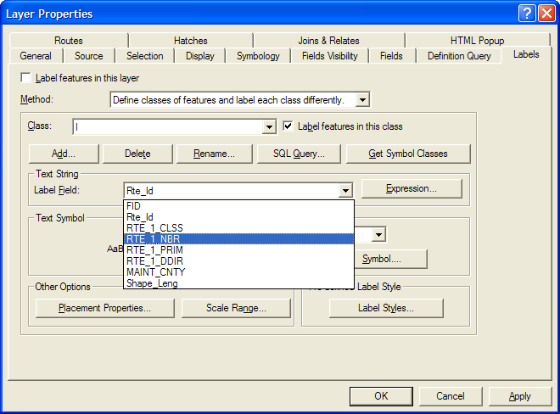

Next click the ‘Symbol’ button. This will bring up the ‘Symbol Selector’ box that will allow you to select the type of label you want to display. Select the ‘U.S. Interstate HWY’ symbol and press ‘Ok’.

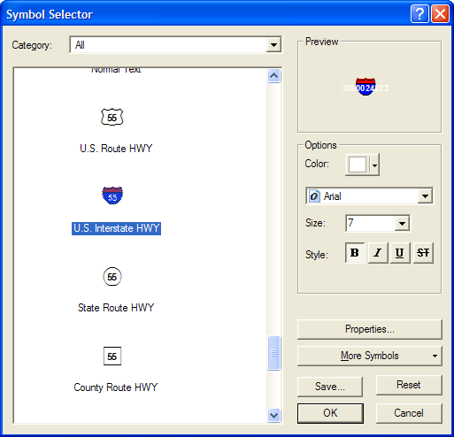

Next we have to position the label. Click the ‘Placement Properties’ button. This will bring up the ‘Placement Properties’ box. Change the ‘Orientation’ to ‘Horizontal’ and click ‘Ok’.
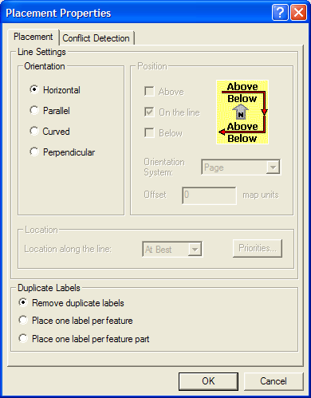

From the ‘Class’ dropdown individually select each class and change their labels.

Class | Label Field | Symbol | Placement
NC | RTE_1_NBR | Other Route HWY | Horizontal
US | RTE_1_NBR | U.S. Route HWY | Horizontal

For the classes ‘SR’ and ‘<all other values>’ uncheck the box ‘Label features in this class’. Finally, check the ‘Label features in the layer’ box to activate the labels.

11. Switch to the layout view and create a layout of your county. Be sure to include a title, legend, north arrow, and scale bar. When you are done export your map as a pdf.

