Objective
The main goal for this exercise is to create a GIS project for analyzing North Carolina Census Tract demographics. The focus of this exercise will be learning how to join tables (with geographic data and spreadsheet data). This exercise will also cover basic functions of working with tables. A choropleth map of NC census tracts illustrating a census demographic will be produced.

Skills
After completing this exercise, the user should be familiar with joining a spreadsheet (table) to a geographic boundary shapefile. The user should also be knowledgeable on sorting fields in a table and making selections from a table.

Data
The geographic boundary data used for this exercise includes North Carolina census tract boundaries (downloaded from NC One Map nconemap.com). The spreadsheet/table data was downloaded from the US Census Bureau (census.gov).

The GIS Project

1. Open ArcCatalog. Navigate to the Map1 folder to verify the data is present. We will be using two files for this exercise – NCTractBoundaries.shp and NCTractsDemographics.xls. Note: The .xls file can be expanded by clicking the + sign next to the filename.
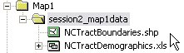

2. In ArcCatalog, open ArcMap. Click the launch ArcMap icon. The ArcMap program should begin to startup.

3. When the program loads, a starting window in ArcMap will appear. Select Start using ArcMap with A new empty map.
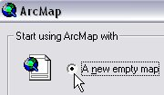

4. Add data to the project. Click the Add Data icon. In the Add Data window, navigate to the files that will be used for this project. First, add NCTractBoundaries.shp. The geographic boundaries file should be viewable in the map display window.
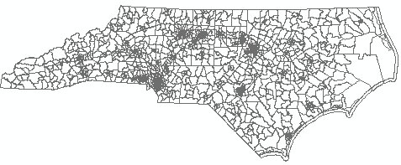

5. View Attribute Table. Right-click the file name NCTractBoundaries and select Open Attribute Table. The attribute table displays information about the file. Notice the field titled STFID. This is the unique identifier for each census tract boundary. This field will be used for joining (later in the exercise). Close the table.

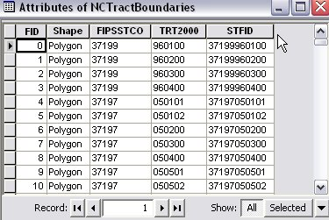

6. Continue to add data to the project. Click the Add Data icon. In the Add Data window, navigate to the files that will be used for this project. Add the table with the demographic data that will be joined to the geographic boundaries – NCTractDemographics.xls > NCTractDemographics$ .The table was added to the project and the file name should show up in the table of contents.

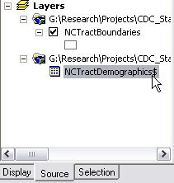

7. View the Table. Right-click the file name NCTractDemographics$ and select Open. This table includes all of the demographic data associated with each census tract. Notice the field titled STFID. This is the unique identifier for each census tract boundary. This field will be used for joining (as mentioned above). Close the table.

8. Join the table to the geography. Right-click the NCTractBoundaries file and select Joins and Relates > Join. The Join Data window should appear.
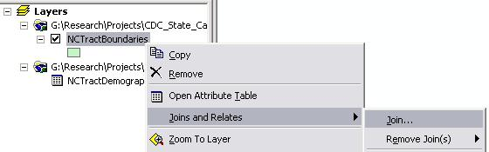

9. Complete the Join Data window. In the Join Data window, choose Join attributes from a table. In the next drop-down menu (1 Choose the field in this layer that the join will be based on), choose STFID, the unique identifier that was previously mentioned. In the next drop-down menu (2 Choose the table to join to this layer…), choose the NCTractDemographics$ table (check the box for Show the attribute tables of layers in this list). In the next drop-down menu (3 Choose the field in the table to base the join on), choose STFID, the unique identifier. For Join Options, select the option to keep all records. See illustration below. Click OK.

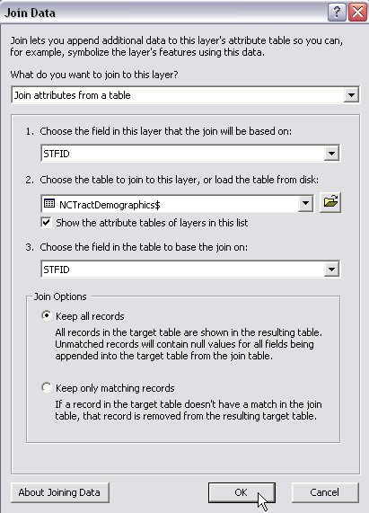

10. The table has been joined to the geographic boundaries. Verify the join. Open the attribute table of the tract boundaries file. Right-click the file name NCTractBoundaries > Open Attribute Table. The geographic boundaries should all have census demographics joined to them. Close the table.

11a. Create a map with a census demographic. With the newly joined files, choose a census demographic from the NCTractBoundaries file and display values with a color ramp. For this example, use the population field (POP2000).

11b. Right-click NCTractBoundaries and choose Properties. The Layer Properties window should appear.

11c. In the Layer Properties windows, navigate to the Symbology tab. In the left-hand menu, show Quantities > Graduated colors. A new menu should appear in the Layer Properties window.

11d. In the Fields menu, change Value to POP2000 (leave Normalization as none). In Classification (a new window will appear after clicking Classify), change the Method to Quantile (then click OK). Optional: change the Color Ramp. Click OK. The NCTractBoundaries should be symbolized in the display window.

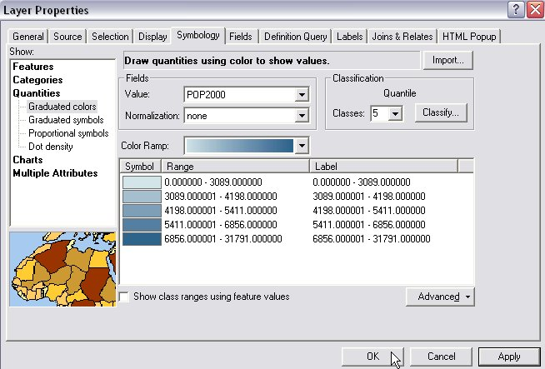

12. Optional: Change the View to Layout View and add map elements. When finished, export map as a PDF for print or email.

