Prenatal Screening for Group B Streptococcus
(Pigmented broth, plate subculture only for isolation and identification)

Annual Review:
Name/Title | Signature | Date

Revision History:
Revision # | Control # | Changes made to document section | Author | Date
Approval Signatures:
Approved by: _______________________________ Date: __________________
Author
____________________________________________________________
Print Name and Title

Approved by: _______________________________ Date: __________________
Supervisor/Technical Specialist-Director ____________________________________________________________
Print Name and Title

Approved by: _______________________________ Date: __________________
Quality Manager
____________________________________________________________
Print Name and Title
Purpose/Principle:
The purpose of this document is to provide instructions for performing prenatal screening for Group B Streptococcus from appropriately collected vaginal/rectal specimens using pigmented broth enrichment with plate subculture if needed to detect non-pigmented strains.

Scope:
This document applies to laboratory assistants, technicians and technologists within the Division of Microbiology at XXXX.

Related documents:
- Provider procedure for collection of specimens for Prenatal Screening for Group B Streptococcus - # xxxx. Note: Procedure should specify the acceptable specimen is a vaginal-rectal swab and that swabs from other sites (e.g. cervical or perianal swabs only) are not acceptable. Procedure should list acceptable type of swab and transport medium.
- Quality Control procedure for tube and plated media - # xxxx.
- Procedure for the identification of streptococci - # xxxx.
- Notification procedure for positive Prenatal Screening for Group B Streptococcus - # xxxx.
- Procedure for susceptibility testing of Group B Streptococcus - # xxxx.

Responsibility:
- It is the responsibility of the technical staff of the microbiology laboratory to review and assure they are familiar with the processes outlined in this document which are within their job duties.
- It is the responsibility of the technical specialist to keep this procedure updated and current with national standards/guidelines/recommendations.
- It is the responsibility of the microbiology supervisor to accurately train and assess the competency of all microbiology staff involved in performing this procedure.
- It is the responsibility of the microbiology data technologist to assure that reporting of all results is appropriate in all computer systems.
- It is the responsibility of the technical director to approve this procedure on an annual basis.

Definitions:
N/A

Equipment/Materials:
- Strep B Carrot Broth™ (Hardy Diagnostics, Santa Maria, CA), Granada™ Biphasic Broth (bioMérieux, Inc., Durham, NC), Northeast Laboratory GBS screening medium (Northeast Laboratory Services, Waterville, ME) or other pigmented selective enrichment and identification broth that incorporates chromogenic pigments.
- Agar plates for subculture (available from a variety of manufacturers): Sheep blood agar, neomycin-nalidixic acid (NNA) agar, Columbia colistin and naladixic acid (CNA) agar with 5% sheep blood, or other selective Streptococcus agar; GBS Detect™ agar (Hardy Diagnostics, Santa Maria, CA); CHROMagar™ StrepB (distributed by Gibson Laboratories, LLC, Lexington, KY), ChromID Strepto B agar (bioMérieux, Inc., Durham, NC), or other chromogenic medium designed for detection of Group B Streptococcus, including non-ß-hemolytic strains.
3. Sterile loops
4. Incinerator
5. Incubator

Quality Control:
Follow Quality Control procedures for tube and plated media - # xxxx.

Safety Precautions:
Use standard precautions when performing this procedure.

Procedure: (Appendix includes one-page flowchart)
- Remove patient specimen (swab; swabs) from transport medium. Specimens should be processed within 4 days of collection. Specimens requiring more than 24 hr of transport time should be refrigerated until received and processed by the laboratory.
- Inoculate the swab(s) into a pigmented selective enrichment and identification broth, such as Strep B Carrot Broth™, or Granada™ Biphasic Broth, or Northeast Laboratory GBS screening medium according to the manufacturer’s directions for leaving the swab in or not, tightly closing the tube, etc. [Before inoculating into broth, laboratories may choose to direct plate by rolling the swab(s) on a sheep blood agar plate, NNA agar, CNA agar, chromogenic agar or other selective Streptococcus agar. If Group B Streptococcus is identified from the primary plate, report Group B streptococcus positive on the culture report. If Group B Streptococcus is not identified, primary plate should be discarded, and enriched broth processed as per protocol below and results reported out from enriched broth].
- Incubate the inoculated pigment broth for a minimum of 18-24 hours at 35-37ºC or the length of time and conditions recommended by the manufacturer.
- If the color indicator for the presence of Group B Streptococcus as specified by the manufacturer is observed, report as positive for Group B Streptococcus.
- If there is no color change in the pigmented selective broth, subculture the incubated broth to a sheep blood agar plate, NNA agar, CNA agar, other selective Streptococcus agar; GBS Detect™ agar, or chromogenic medium such as CHROMagar™ StrepB, ChromID Strepto B agar that will detect non-hemolytic Group B Streptococcus and incubate for a minimum of 18-24 hour at 35-37ºC in 5% CO₂ or as recommended by the manufacturer.
- Inspect and identify colonies characteristic of Group B Streptococcus (i.e., gram-positive cocci, catalase negative, narrow zone of β-hemolysis or no hemolysis) using routine laboratory identification protocols or procedures recommended by the manufacturer for selective and chromogenic media. (Refer to procedure # xxxx – Procedure for the identification of streptococci).
- If Group B Streptococcus is not identified, reincubate the agar plate for an additional overnight incubation to identify suspected Group B Streptococcus organisms. If a chromogenic medium is used, additional incubation may not be required; follow manufacturer’s instructions.
- Report as negative for Group B Streptococcus when no Group B Streptococcus has been recovered.
- If Group B Streptococcus is identified, report as Group B Streptococcus positive on the culture report.
- If the positive specimen is from a penicillin-allergic patient at high risk for anaphylaxis, perform susceptibilities for clindamycin and erythromycin, including inducible clindamycin resistance, using appropriate laboratory susceptibility procedures. (Refer to protocol # xxxx – Procedure for susceptibility testing of Group B Streptococcus.)

Format:
N/A

Reference:
MMWR Recomm Rep. 2010 Nov 19;59(RR-10):1-36. Prevention of perinatal group B streptococcal disease--revised guidelines from CDC, 2010. Verani JR, McGee L, Schrag SJ; Division of Bacterial Diseases, National Center for Immunization and Respiratory Diseases, Centers for Disease Control and Prevention (CDC).
Experts from the American Society for Microbiology (ASM) and the Centers for Disease Control and Prevention’s (CDC) Streptococcus Laboratory co-authored this document.*

For more GBS laboratory resources, visit http://www.cdc.gov/groupbstrep

*Collaboration does not imply HHS/CDC endorsement of ASM
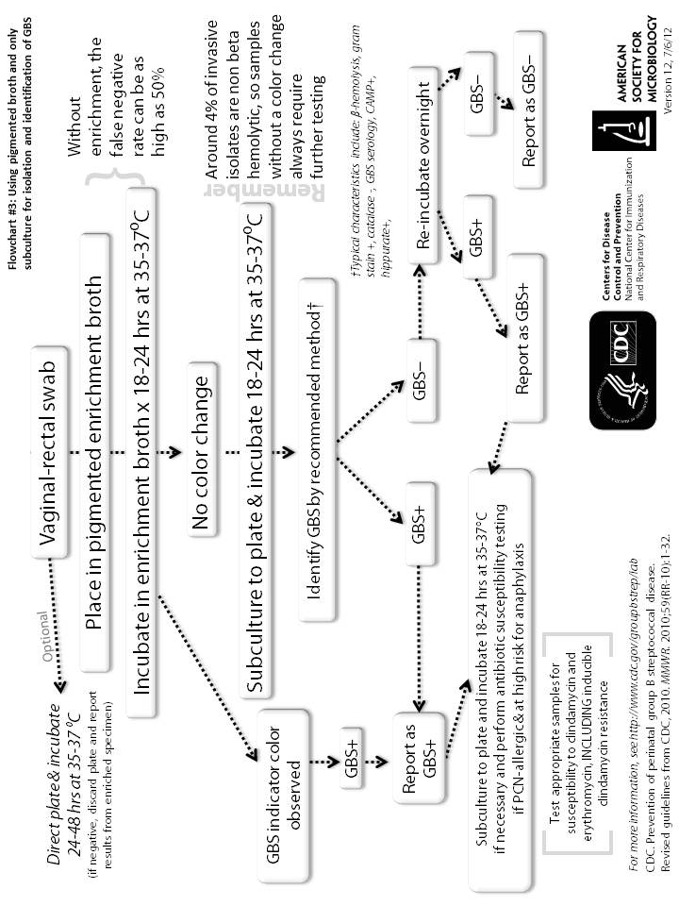
Appendix: Flow diagram for Prenatal Screening for Group B Streptococcus: Pigmented broth, plate subculture only for isolation and identification.

