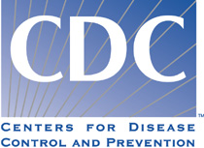 | National Center for Emerging and Zoonotic Infectious Diseases (NCEZID)  National Center for Environmental Health (NCEH)  National Center for Injury Prevention and Control (NCIPC)

Health Promotion Tool Kit

Recreational Water Illness and Injury (RWII) Prevention Week: May 21–27, 2012

Suggestions for how state and local programs can engage community partners and links to relevant information on CDC’s Healthy Swimming and Injury Prevention websites are provided below.

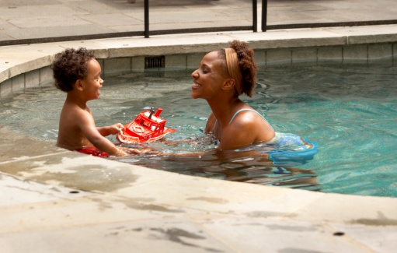
All Audiences
- Announce RWII Prevention Week — May 21–27, 2012.
- Create an RWII Prevention Week page on your agency’s website if one does not already exist. You can also copy pages from CDC’s Healthy Swimming and Injury Prevention websites to put on your own website, while still maintaining the look and feel of your website (content syndication). Please contact healthywater@cdc.gov for more information.
  - Include links to CDC’s Healthy Swimming and Water-Related Injury Prevention websites and EPA’s Beaches website.

Media
- Provide a release to media outlets.
- Share information, such as:
    - Water safety and drowning prevention information, and the latest data on fatal and nonfatal drowning.
    - How health communication campaigns can mitigate and prevent recreational water illness (RWI) outbreaks, and data on RWI outbreaks in your community.
    - How germs that cause RWIs are transmitted and the Six Steps for Healthy Swimming (found on the “Triple A’s of Healthy Swimming” webpage, listed below).

Community Leaders
- Create fact sheets detailing specifics about local and state RWII Prevention Week efforts for community leaders (e.g., program administrators, boards of health, elected officials).
- Provide suggested resolutions (e.g., proclamations) related to RWII Prevention Week for use by area decision makers.

Aquatic-Facility Operators and Beach Managers
- Encourage pool operators and beach managers to adopt and promote this observance.
- Promote learn-to-swim and CPR training opportunities as a community drowning prevention strategy.

Swimmers and Parents
- Provide information on preventing recreational water injuries and illnesses.
- Promote RWI prevention recommendations by providing/posting Healthy Swimming posters and brochures.
- Link to the 2011 Healthy Swimming Video Contest winner.

Healthcare Providers
- Provide water health and safety education materials to promote prevention of illness and injury.
- Engage in activities of your local chapter of the American Academy of Pediatrics (AAP), http://www.aap.org/, or other organization for healthcare professionals.

Let us know about your activities related to Recreational Water Illness and Injury Prevention Week: ehsb@cdc.gov

Links to CDC Healthy Swimming Information and Resources

General Information
CDC’s Water-Related Injury Prevention Site |  | www.cdc.gov/HomeandRecreationalSafety/Water-Safety/index.html
CDC’s Healthy Swimming Site |  | www.cdc.gov/healthywater/swimming
FAQs |  | www.cdc.gov/healthywater/swimming/faq/index.html
Press and Matte releases |  | www.cdc.gov/healthywater/swimming/newsroom/press-releases/
Overview of RWIs |  | www.cdc.gov/healthywater/swimming/rwi/
Healthy Swimming and Injury Prevention Resources
Injury & Skin Cancer Prevention | www.cdc.gov/healthywater/swimming/injury/
Healthy Swimming Brochures/Posters | www.cdc.gov/healthywater/swimming/resources
Triple A’s of Healthy Swimming  (includes 6 Steps for Healthy Swimming) | www.cdc.gov/healthywater/swimming/pools/triple-a-healthy-swimming.html
Healthy and Safe Swimming Podcasts | www.cdc.gov/healthywater/swimming/resources/podcasts.html
Healthy Swimming Video Contest | www.cdc.gov/healthywater/swimming/rwi/video-contest.html
Swim Diapers/Swim Pants | www.cdc.gov/healthywater/swimming/pools/swim-diapers-swim-pants.html
Information about Chlorine and pH | www.cdc.gov/healthywater/swimming/pools/disinfection-team-chlorine-ph.html
Model Aquatic Health Code | www.cdc.gov/healthywater/swimming/pools/mahc/
Resources for Public Health Professionals
Healthy Swimming Data/Statistics and Outbreak Reports | www.cdc.gov/healthywater/swimming/data/  www.cdc.gov/mmwr/pdf/ss/ss6012.pdf
Pathogens Transmitted at Recreational Water Venues | www.cdc.gov/healthywater/swimming/resources/fact-sheets/#illnesses
Online Environmental Public Health Training: Swimming Pools and Recreational Facilities | www.cdc.gov/nceh/ehs/eLearn/EPHOC.htm
Resources for Aquatic-Facility Operators
Fecal Incident Response Recommendations | www.cdc.gov/healthywater/pdf/swimming/pools/fecal-incident-response-recommendations.pdf
Recommendations for Preventing Pool Chemical–Associated Injuries | www.cdc.gov/healthywater/swimming/pools/preventing-pool-chemical-injuries.html
Recreational Water Illness: What Every Clinician Needs to Know | http://emergency.cdc.gov/coca/calls/2011/callinfo_062811.asp
Swimmer’s Ear (provided in collaboration with the American Academies of Pediatrics and Otolaryngology) | http://aapnews.aappublications.org/content/32/6/1.2.full  http://aaobulletin-365.ascendeventmedia.com/highlight.aspx?id=3114&p=284
Open Water Resources
EPA’s Beaches Website | http://water.epa.gov/type/oceb/beaches/index.cfm
General info: Oceans, Lakes, Rivers | www.cdc.gov/healthywater/swimming/oceans/

