Don’t Go Overboard:
Before you go swimming this season,
protect yourself and your family from
Recreational Water Illnesses (RWIs)
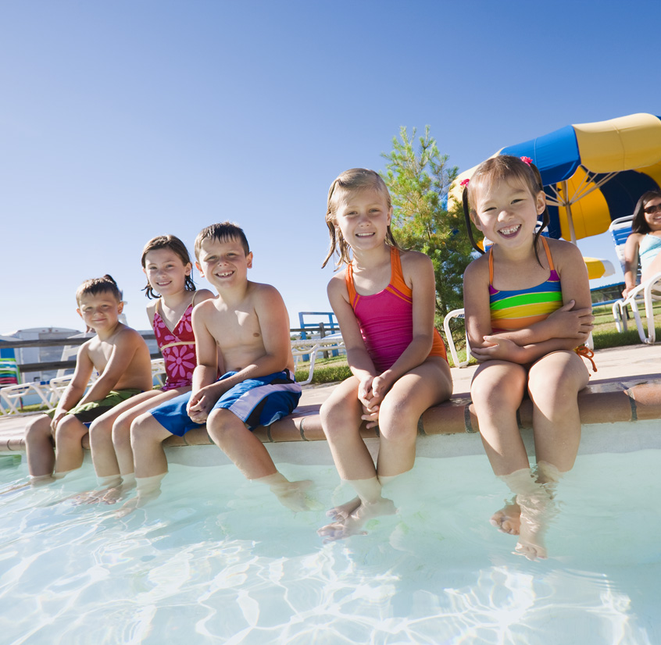
Jupiter Images
Swimming season is upon us. The skies are blue, and warm weather has returned. It’s time to break out the swim suits, lather on the sunscreen, and head to the local pool.
Swimming and other water-related activities such as water skiing and boating are excellent ways to spend leisure time and to engage in physical activity. However, it is important for everyone to follow basic guidelines to prevent Recreational Water Illnesses (RWIs).
RWIs are illnesses that are spread by swallowing, breathing in the vapors of, or having contact with contaminated water. Although most water is not contaminated with germs that cause illness, swimming pools, water parks, spas, interactive fountains, lakes, rivers, oceans, and other types of recreational water are all potential sources that can lead to the spread of germs that cause RWIs.
The most common RWI is diarrhea, and it is often caused by germs such as Cryptosporidium (“Crypto”), Giardia, Norovirus, Shigella, and E. coli O157:H7. Other common RWIs include skin, ear, respiratory, eye, neurologic, and wound infections. Anyone can get RWIs; however, children, pregnant women, and people with weakened immune systems are most at risk for these types of illnesses.
The Centers for Disease Control and Prevention (CDC) in Atlanta, Georgia reports that since the mid 1980s, there has been a steady increase in outbreaks of diarrheal illness linked to recreational water. This is primarily due to the emergence of the chlorine-resistant parasite Cryptosporidium (or “Crypto”). This one germ now accounts for over two-thirds of all pool-associated diarrheal outbreaks.
Although outbreaks have become more frequent, recreational water illnesses are preventable. There are a number of simple steps the public, aquatics staff, and public health officials can take to help keep germs out of recreational water. For example, some people mistakenly believe that chlorine immediately kills germs in pools. This common misconception might lead people to do risky things, like swimming while ill with diarrhea.
CDC recommends that pool users follow the “Six STEPs” for Healthy Swimming to stop germs from getting in recreational water and causing illness:
- Please don’t swim when you have diarrhea.
- Please don’t swallow pool water.
- Please shower with soap before swimming and wash your hands after using the toilet or changing diapers.
- Please take your kids on bathroom breaks or check diapers often.
- Please change diapers in the bathroom or diaper-changing area and not at the poolside.
- Please wash your children thoroughly (especially the read end) with soap and water before they go swimming.
When swimming in natural waters, such as lakes, rivers, and oceans, avoid swimming after a heavy rain or near storm drains. Be aware of signs of pollution that may indicate the presence of disease-causing bacteria.
For more information on CDC’s Healthy Swimming Program, including RWI prevention, please call 1-800-CDC-INFO or visit the web site at http://www.cdc.gov/healthyswimming.

