Recreational Water Illness (RWI) Prevention: Take action and stay healthy!

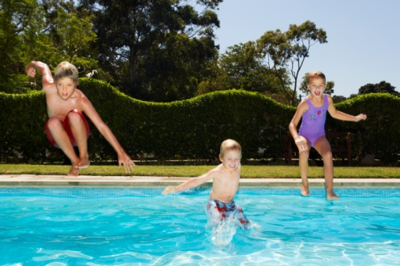
Thinkstock

Swimming is great exercise with many health benefits, but the water you swim in can also spread germs that can make you sick and cause illnesses known as recreational water illnesses (RWIs).

The germs that cause RWIs are spread when you swallow, breathe in the mists from, or have contact with contaminated water from pools, water parks, hot tubs, lakes, oceans, and any other type of water used for recreation.
Since the mid-1980s, the number of reported RWI outbreaks has increased substantially, according to the Centers for Disease Control and Prevention (CDC). The most common recreational water illness is diarrhea, which is often caused by the germs Cryptosporidium (“Crypto”) and Giardia. Other common RWIs include skin, ear, respiratory, eye, neurologic, and wound infections.
The best way to prevent illness when swimming is to stop the germs from getting into the water and to make sure that recreational water facilities properly filter and disinfect the water. Although pool inspectors check to make sure these facilities are properly maintained, they can’t be at every pool every day.

A CDC study found that 1 in 8 public pool inspections conducted in 13 states in 2008 resulted in pools being closed immediately due to serious code violations. Overall, child care pools had the highest percentage of inspections resulting in closures (17.2%), followed by hotel/motel pools (15.3%), and apartment/condo pools (12.4%).

To help stay healthy every time you swim, take an active role in stopping the spread of germs by following the Triple A’s of Healthy Swimming: Awareness, Action, and Advocacy.

Awareness
- Visit CDC’s Healthy Swimming website www.cdc.gov/healthywater/swimming to learn more about staying healthy.
- Follow the Six Steps for Healthy Swimming.
    - Don’t swim when you have diarrhea.
    - Don’t swallow pool water.
    - Practice good hygiene. Shower with soap before swimming and wash your hands after using the toilet or changing diapers.
    - Take your kids on bathroom breaks or check diapers often.
    - Change diapers in a bathroom or a diaper-changing area and not at poolside.
    - Wash your child thoroughly (especially the rear end) with soap and water before swimming.

Action
- Check pool water yourself using test strips purchased at your local hardware or pool supply store. CDC recommends the following water quality ranges to kill germs:
  - free chlorine levels at 1–3 parts per million (ppm)
  - pH 7.2–7.8
- Ask the pool operator:
  - Are the free chlorine and pH levels checked at least twice a day and more often when the pool is heavily used?
  - What is the latest pool inspection score?
  - Has the operator completed specialized training in pool operation?

Advocacy
- Encourage pool operators to take steps known to kill germs.
  - Add ultraviolet or ozone technology to treat water or Hyperchlorinate (add additional chlorine to the pool) regularly
- Educate others about RWIs and promote healthy swimming behaviors.

