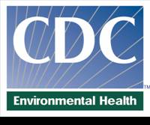
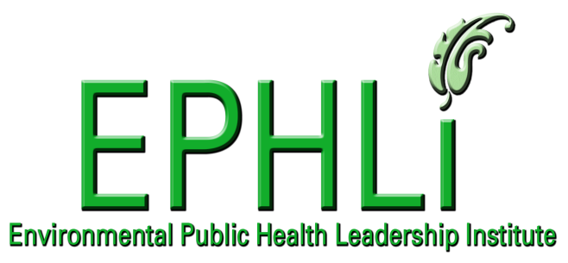

CDC Environmental Public Health Leadership Institute
Graduate Presentations
Class of 2009–2010

Chamblee Campus, Building 106

Conference Room 1A–B

February 23, 2010
8:45–9:20 am Welcome and Keynote Address
9:20–10:20 am Graduate Oral Presentations
From Occupation to Profession: The Evolution of a Career
—Margaret Blood, REHS
Street Feeding in St. Petersburg: A Tale of Two Cities
—Gayle Guidash, MPH
A Local Health District’s Role in Building a Sustainable Community
—Robert Hasenyager, RS, MS
10:20–11:30 am Graduate Poster Presentations (listed by topic on page 2)
12:00–1:00 pm Graduate Oral Presentations
Community Engagement for Food Protection: Building A Balanced, Sustainable Model to Protect the Health of the Public
—Tim Jenkins, MPH, REHS, and Kendra Kauppi, PhD,MS
Pesticides, Disinfectants and Our Children, Oh My! Safeguarding Kids in Childcare—Amy Meese, MPH
A Pilot Program to Improve the Quality of Sanitary Surveys of Public Water Systems—Ralph Van Houten, MS

EPHLI is a 1-year program of seminars and workshops, special projects, and individual study. Each year, about 30 practicing environmental public health professionals are admitted to the program.
Applications for new cohorts are accepted each fall.
http://www.cdc.gov/nceh/ehs/ephli

Graduate Poster Presentations, Class of 2009–2010
Air Quality
- Developing a Strategy for Addressing Air Quality Impacts in the San Joaquin Valley—Debbie Lowe Liang, MPH
- Tank Barges: An Unforeseen Emission Source—James Holt, MS
Biosolids
- Biosolids: The Search for a Final Resting Place—Keith Hunter, RS, MPH
Children’s Environmental Health
- Exploring a Model to Address Children’s Environmental Health Issues in Africa—Aurora Amoah, MPH
- Implementation of an Asthma Program in South Texas Elementary Schools—Genny Carillo Zuniga, MD, MPH, ScD
Climate Change
- Changing Our Ways: Tackling Climate Change in State Health Agencies—Gino Marinucci, MPH
Community Environmental Health Assessment
- Using PACE-EH to Improve and Sustain Health and Safety Conditions in the Marydia Community of Osceola County, Florida?—Bret Smith, MPH
- Effective Communication: Demonstrating the Need for Open, Honest, and Timely Responses to Stakeholder Concerns—Susan Shearer, MPH, PE
- Developing an Annual Environmental Health Report for the Oneida Nation of Wisconsin—Jennifer Falck, RS, EHS
Credentialing
- An Internationally Registered Environmental Health Specialist Qualification (IREHS)—Jason Finley, REHS, CHMM, CPT, MS, KYARING
Drinking Water
- Identifying Stakeholders' Practices and Concerns About Pharmaceuticals: A Qualitative Study—Julie Becker, PhD, MPH
Emergency Shelter Standards
- Development of Minimum Standards for Emergency Shelter Operations in Sharp County, Arkansas—Jeff Jackson, RS
Environmental Health Programs
- New Approaches to Reducing Vibrio Parahaemolyticus Infections from Shellfish Consumption—John McVeigh, MBA, CHO, RS
- Implementation of Quality Management System in the Environmental Health Programs of the Green River District Health Department—Clayton Horton, MPH
- Improving Monitoring and Evaluation of Environmental Public Health in Maryland—Rebecca Love, MPH, CHES

Environmental Public Health Performance Standards
- Why Incorporating the CDC’s Environmental Health Performance Standards Will Assist in Building Capacity in Environmental Health Services in the State of Georgia—Kevin Jones, MPA
Food Safety
- Improving Pulsed Field Gel Electrophoresis (PFGE) Clustered Investigations in Florida— Becky Lazensky, MPH, and Ryan Lowe
- Assessment of Food Safety Program: Enrollment in FDA’s Voluntary National Retail Food Regulatory Program Standards—Matthew Ringenberg, MPH
- Enhancing the Public and Restaurant Industry to Enhance Food Safety in Portland, Maine—Michael Russell, MS, MEP
GIS
- Using Geographic Informational Systems (GIS) in Environmental Public Health—Sheila Davidson Pressley, MS
Indoor Air Quality
- Why Has Know County Failed to Implement a Successful Indoor Air Quality Education Campaign?—William Hayes, BA, LEHP
Lead Poisoning
- Improving the Quality of Childhood Lead Poisoning Investigations in Michigan—Michele Borgialli, MPH, MSW
- Improving Education Prevention to Help Reduce Lead Poisoning in the City of Philadelphia—Jill Ann Coleman, BS
Pest Control
- Legislative Challenges to the Control of Emerging Public Health Pests and Zoonotic Diseases in North Carolina—Amadou Jallow, BS
Recreational Water
- Safe Swimming: A Call for Stakeholders to Become Involved—Angeline DeWald, BS, RS
Regulatory Enforcement
- Assuring Environmental Health and Safety by Improving Enforcement of Ordinances—Rhonda Bartow, MA, REHS/RS
Workforce Development
- Developing a Comprehensive Workforce Development Plan to Retain and Recruit Environmental Health Specialists in the State of Georgia—Chris Rustin, MT, REHS

