Appendix C. State of TN Community Health Record (CHR) Infrastructure. CHR tool infrastructure, utilizing Open Source and Open Data standards via the construction of an Open infrastructure. It includes 1) the implementation of an evolving industry standard data store (mongoDB) and warehouse (Hadoop); 2) the implementation of a federated data gateway utilizing CKAN, a nodal framework supports simplified cross-pollination of emerging data stores; and 3) the use of WEAVE ANALYTICS AVR infrastructure, a next-generation Business Intelligence (BI) platform supporting the construction of task-specific analytic views of the federated data http://iweave.com/.

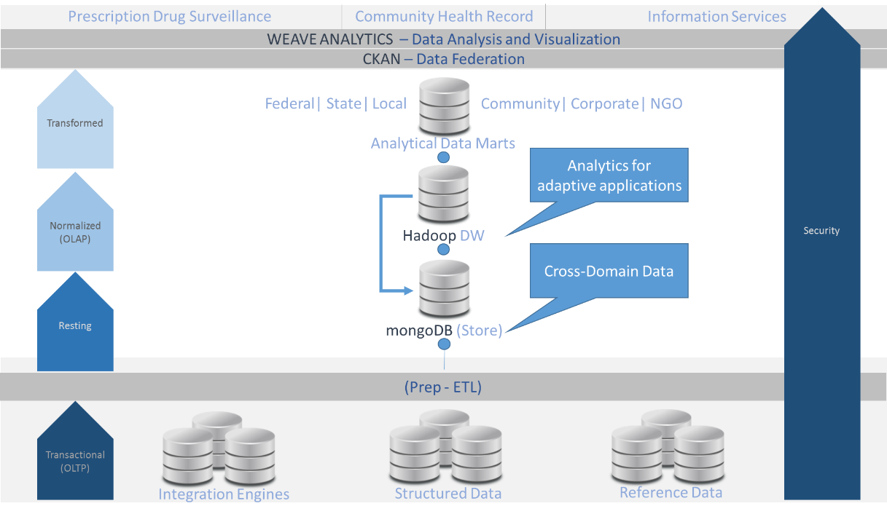
*The implementation is contingent on existing technical infrastructures, and may be substituted with like solutions as both the technologies and framework evolve.

