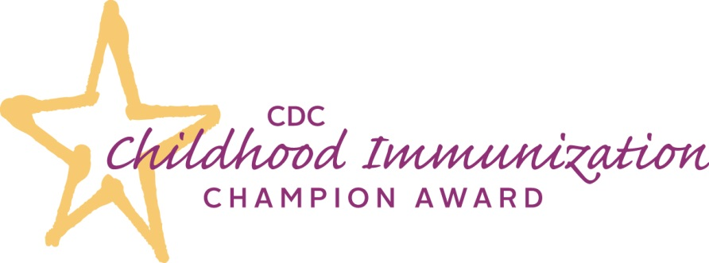

**Who is a *CDC Childhood Immunization Champion*?**

An individual who meets one or more of the following criteria:

* **Leadership:** The candidate is considered an authority on immunization in An
* **Collaboration**: The candidate has worked to build support for and increase immunization rates in infants and young children. Activities may include establishing or strengthening partnerships, coalitions, committees, working groups, or other.
* **Innovation:** The candidate has used creative or innovative strategies to promote immunization or address challenges to immunization in his or her practice, community, state, or region. Activities may include both new strategies and adapting existing strategies in new ways, such as for reaching under-immunized populations.
* **Advocacy:** The candidate is active in advancing policies and best practices to support immunization in infants and young children in his or her community, state, or region. Activities may include providing legislative testimony or promoting, analyzing, or evaluating policies.

*Immunization program managers; county, state, and federal government employees paid with immunization funding; and individuals affiliated with and/or employed by pharmaceutical companies are* ***not*** *eligible to apply.*

To learn more about the *CDC Childhood Immunization Award* and to nominate a

*Champion* visit [*www.cdc.gov/vaccines/champions*](https://www.cdc.gov/vaccines/champions)



The ***CDC Childhood Immunization Champion Award*** is an annual award during National Infant Immunization Week (NIIW), **April 22-29, 2017** to recognize individuals who make a significant contribution toward improving public health through their work in childhood immunization.

Each year, up to one *CDC Immunization Champion* from each of the 50 U.S. states, 8 U.S. Territories and Freely Associated States, and the District of Columbia will be honored.

**How do I nominate a Champion?**

Submit a nomination form to your state or territorial immunization program manager by **February 3, 2017**. Self-nominations are welcome. *Champions* can include coalition members, parents, health care professionals (e.g., physicians, nurses, physicians’ assistants, nurse practitioners, medical assistants, etc.), and other immunization leaders who meet one or more of the award criteria.

**How will Champions be recognized?**

Awardees will be announced during National Infant Immunization Week (NIIW), **April 22-29, 2017**. *Champions* will receive a certificate of recognition, will be featured on CDC’s website, and may be recognized by their immunization program during NIIW.