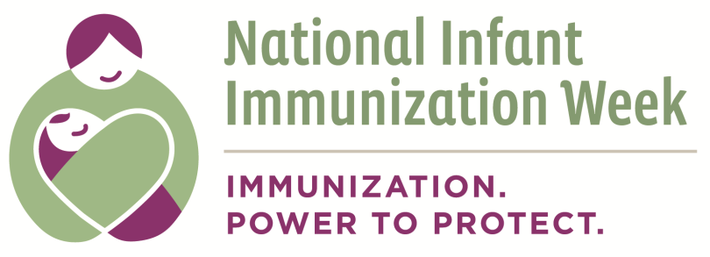

Appendix A: Identifying Partners Worksheet

Types of resources or benefits to be gained from partners | What do you need to achieve you NIIW Objective?  (For each category that applies, be specific. Examples in italics.) | Who might be able to provide this? | Do they meet our selection criteria?  (Yes or No)
Services | Interpretation services for Vietnamese-speaking parents
Information | Best practices for reaching parents with children under 2
Funding | Funding to print immunization schedules
Volunteers | Distributing flyers about upcoming clinic
Facilities | Meeting and conference rooms
Access/Reach in community | Ties with African American community
Visibility | Media coverage for immunization clinic
Experts | Spokesperson for TV interview about vaccine safety
Influence | Influence among health care providers
Other (e.g. share staff)
This document can be found on the CDC website at: http://www.cdc.gov/vaccines/events/niiw/index.html

