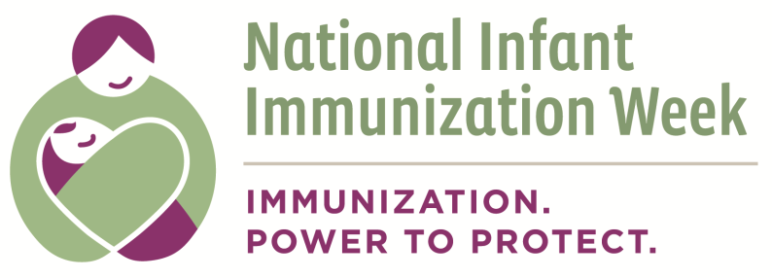

Appendix B: Partnership Selection Criteria Worksheet
*Examples are provided in italics

Self-Assessment Questions | Criteria * | Indicator * | Rationale *
What do we want in a partner? | Has established relationships with mothers of under-immunized children younger than 2 years old | Organization/Program location  Description of beneficiaries/clients | By partnering with this type of organization, our group/coalition will be able to:  - expand its reach to areas of under and un-immunized children younger than 2 years old  - gain access, credibility, and the trust of community members  - learn about their knowledge, attitudes, and behaviors toward immunizations  - collaborate to address identified barriers and challenges
What do we not want in a partner? | Financial instability | Budget cuts | This type of partner might be a financial burden to the coalition, due to our limited funding sources.
Do we have money to allocate towards these partners? If so, how much and what are the requirements for the partners?
Other:

This document can be found on the CDC website at: http://www.cdc.gov/vaccines/events/niiw/index.html

