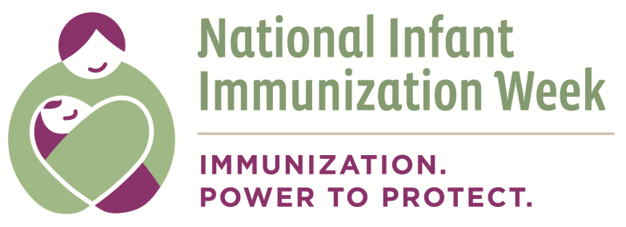

Appendix D: Partnership Agreement Template

A. Partner Organizations

Immunization Coalition
Contact Person
Address
Telephone
Fax
Email
Brief Description

Partner
Organization Name
Contact Person
Address
Telephone
Fax
Email
Brief Description

B. Statement of Intent

We, the undersigned, acknowledge a common commitment to [purpose of partnership].

By working together as partners, we acknowledge the benefits and added value that each of us can bring to fulfill this commitment.

Specifically, we expect each partner to contribute to the joint effort in the following ways:

Immunization Coalition: Partner:

C. Structures and Procedures

1. Partner Roles and Responsibilities
2. Administration (staff, day-to-day activities, contracts, financial oversight)
3. Decision-making Procedures

D. Resources

We will each provide the following resources: [for example, amount of funds, staff time, printed materials]

Immunization Coalition: Partner:

Additionally, we will jointly pursue the following funding opportunities: [for example, foundation grants, government awards, corporate sponsorships]

E. Monitoring Plan

We will review the partnership every [number] months in the following ways: [list ways in which progress will be monitored]

We will make adjustments to this partnership, including revising this agreement, as necessary based on these reviews.

F. Communications

1. Internal
In recognition of the importance of maintaining open communications among the partners, we agree to the following protocol: [i.e. monthly meetings, weekly conference calls, regular e-mail communication]

2. External
In recognition of the need to appropriate represent the partnership, we agree to the following protocol: [outline who will serve as media contacts, process for sharing partnership information, etc.]

*************************************************************
Signed

_____________________________ __________________________
Representative for Representative for Partner
Immunization Coalition

_____________________________ __________________________
Title Title

____________________________ __________________________
Date Date

This document can be found on the CDC website at: http://www.cdc.gov/vaccines/events/niiw/index.html

