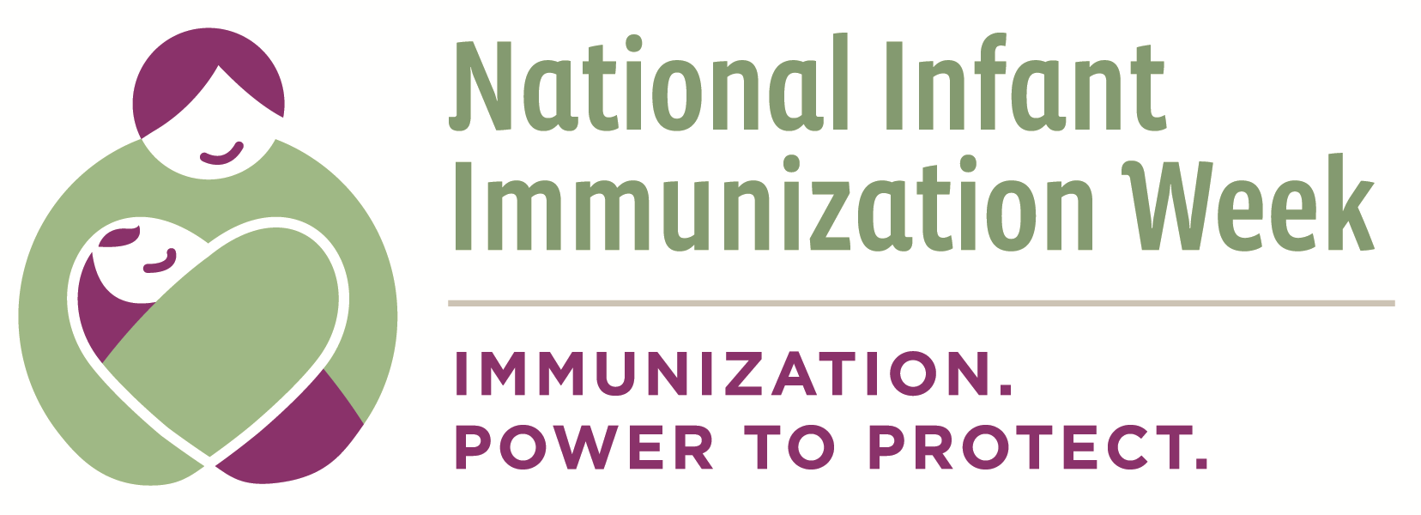

Appendix E: Assessing the Partnership Process

Questions to Consider | If not, what are some barriers to achieving this? | How can we address these barriers?
- Purpose
- Is there a partnership agreement? Do all partners understand and respect this agreement?
- Is there a clear plan for achieving shared goals?
- Leadership
- Is there senior level commitment to the partnership?
- Is it clear who is responsible for the progress of the partnership?
- Communications
- Are there regular systems of communications in place?
- Is information passed on to all partners in a timely and transparent manner?
- Is there a protocol for representing the partnership to the wider community?
- Decision-making
- Is there a decision-making process in place? Is this process followed by all partners?
- Are decisions made openly and in a timely manner?
- Are there significant conflicts between partners? Are they managed effectively?
- Participation
- Do partners participate equally in leadership and decision-making?
- Do partners attend meetings and co-sponsored activities regularly?
- Resources
- Are all partners contributing the resources agreed upon in the partnership agreement?
- Are resources being used efficiently?
- Are there resources still needed to achieve partnership goals?
- Implementation
- Are meetings and activities being implemented according to plan? Are they effective?
- Are there clear lines of accountability for implementing partnership activities?
- Do partners participate equally in implementation of activities?
- Monitoring
- Are there clear outcomes for the partnership outlined in the partnership agreement?
- Is there regular monitoring of the partnership and its activities?

This document can be found on the CDC website at: http://www.cdc.gov/vaccines/events/niiw/index.html

