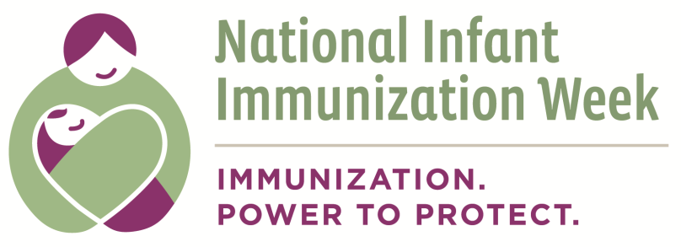

Appendix F: Meeting Partnership Goals
As a result of the partnership: | If yes, provide examples: | If no, what needs to be done to achieve this?
Have new services or programs been developed?
Are resources being used more efficiently?
Does infant immunization have a higher profile within your community?
Has access to services increased?
Has the quality of services improved?
Has the scale and reach of your programs increased?
Have you been better able to advocate for your constituency?
Are there other benefits from this partnership for your coalition/organization?
Are there other benefits from this partnership for your constituents/ organization?

This document can be found on the CDC website at: http://www.cdc.gov/vaccines/events/niiw/index.html

